All Committee positions will be declared vacant as at the AGM on February 15th **2022**, (see separate notice), and nominations are invited for all positions for the **2022** Committee.

|  |  |
| --- | --- |
| _Pic2 | Nomination Form  Officers and Committee, **2022** |

I *(print name)…………………………………………* Member No……………………………………….

Agree to be nominated for the position of: (*tick ONE*)

The 2022 year will have a committee of a maximum of 12 members including Office Bearers.

Nominations for Positions as a Committee Member or Vice President are required to also nominate to take on responsibility for at least one of the roles listed.

Registered Association No: A0020457C ABN: 83 036 957 948

Position

President

Policy and Legal 

Membership & Club Plates 

Scrutineering 

Trackdays 

CAMS Regulations and Officials 

Social Events 

Publications 

Vice President

Treasurer

Secretary

Committee Member

Signature:………………... Date: …...…..…………..

Address:

Suburb:……………………………………………. P/code:

*If you have attended a club event in 2021 and/or are known to a member of the Committee, your nomination can be endorsed by the Committee. Alternatively, please have the nomination seconded (below) by a voting member of the club.*

I *(print name)* Member No………………………

Second the above nomination.

Signature:………………………………………………… Date: …………………………………

Address: ……………….

Suburb: P/code: ………………..

**Please return this form to reach the secretary of the club by 8th February 2022**

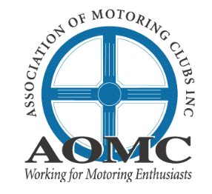



Registered Association No: A0020457C ABN: 83 036 957 948